Mobilgrease XHP 222 Helped GPS extend re-greasing interval, decrease bearings temperature by 5°C & save 5316 EGP/Year
Situation
GPS was using Mobilux EP 2 in bearings lubrication.
Bearings average temperature was 48°C & re-greasing was done every 600 hours, re-greasing quantity was 122.5 KG for each bearing. Bearings were exposed to direct water ingress.
GPS Team aim was to optimize re-greasing quantity used & decrease overall maintenance cost.
Recommendation
EL Zahed Lubrication Engineer recommended Mobilgrease XHP 222 with its super resistance to water washout out & spray-off.
A trial was conducted to monitor water resistance performance, bearings temperature & optimize re-greasing quantity
Benefits
Using Mobilgrease XHP 222 helped GPS to double the re-greasing interval & decrease bearings temperature by 5°C

Reduce safety hazard & injuries risk by
decreasing Man-Machine interface by 36 hours/year

Eliminating 184.5 Kg/year from used grease quantity will positively impact the environment

For more information on Mobil-branded industrial lubricants and services, please contact your local company representative or visit mobilindustrial.com.

© 2013 Exxon Mobil Corporation
Mobil, additional trademarks, and the Pegasus design are registered trademarks of Exxon Mobil Corporation or one of its subsidiaries.
POP-2014-xxx-Distributorcode
* This proof of performance is based on the experience of a single customer. Actual results can vary depending upon the type of equipment used and its maintenance, operating conditions and environment, and any prior lubricant used.
**Visit mobilindustrial.com to learn how certain Mobil-branded lubricants may provide benefits to help reduce environmental impact. Actual benefits will depend upon product selected, operating conditions and applications
Mobilgrease XHP 222 decreased bearings temperature & accordingly better protection Using Mobilgrease XHP 222 helped GPS optimize grease quantity & decrease overall maintenance cost by 5316 EGP/year
Bearing
GPS, Printing
10th of Ramadan City, Egypt

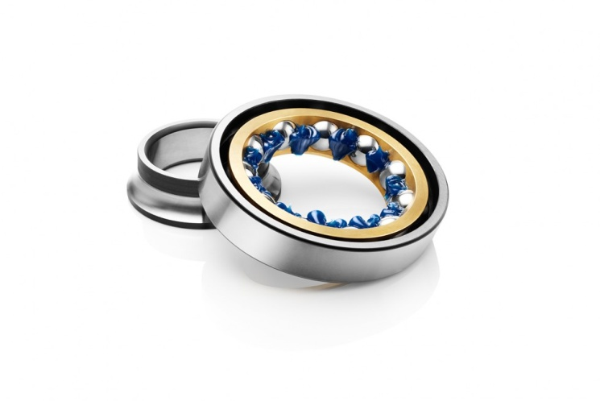

GPS Maintanace Engineer ELZahed Lub Engineer
Eng.Ramy Ammar Eng.Mohamed ELMatrawy

