PROOF OF PERFORMANCE

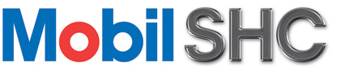

Mobil SHC saves L.E 259000
by saving production loss,
lubricant, labor & filter cost*, provides better protection for equipment.
Textile Factory
Faragtex
Egypt

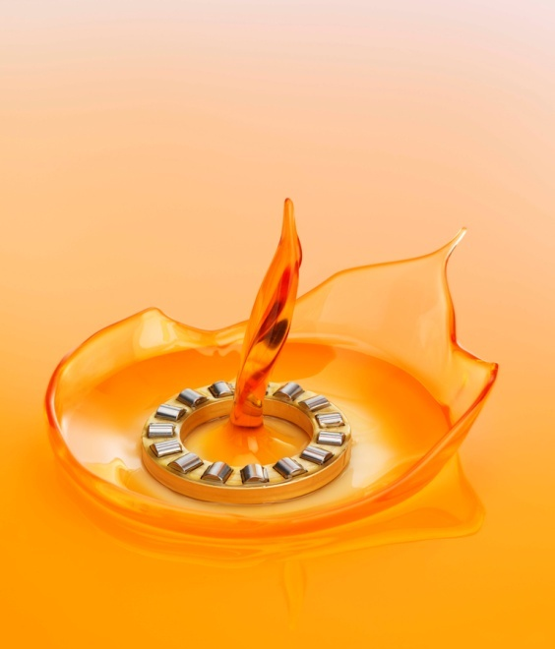
Situation

Faragtex was using Mobilgear 600 XP 150 as gearbox oil in the lubrication of all gearboxes. Customer used to drain oil every 3600 hours. The customer needed to extend drain interval to decrease operational cost.
Recommendation

After conducting plant survey by Elzahed Field Engineering team, gathering technical data/operating parameters the suggested solution was to change (Mobilgear 600 XP 150) to synthetic gear oil (Mobil SHC 629). Being a synthetic base oil lubricant it was recommended to provide an extended drain interval and increase uptime of gearboxes.
Result
Oil drain intervals were extended up to six times from 3500 hrs. to 21600 hrs. The above extention in ODI resulted to increase in up-time of equipment worth of LE 32000. Reduction of oil cost and spare parts cost. Avoiding production loss of 225000 LE due to change oil.

caption

For more information on Mobil SHC and other Mobil Industrial Lubricants and services, please call your local company representative or contact the Technical Helpdesk on TechDeskEurope@exxonmobil.com.
Also visit www.mobilindustrial.com.
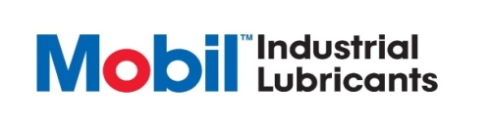

www.mobilindustrial.com

